ME 635 – Modeling and Simulation

Fall 2022

Final Exam

Due Date: 12/16/2022

Report by,

Viral Panchal

“I pledge my honor that I have abided by the Stevens Honor system”

**Solution:**

**Given:**

L = 50 mm = 0.050m

Total length of rod = 2L = 100 mm = 0.1m

D = 5 mm = 0.005m

K = 25 W/mk

$\dot{q}$ = 1e+6 W/ $m^{3}$

***A) Expression for the steady state temperature Tb***

When the embedded portion of the rob is an infinite pin, then 0≤x≤L

Expression for heat transfer rate is given as:

$q_{f}$**= $\sqrt{h_{ρ}KA_{c}}$ ($T_{b} - T_{∞}$) ….Eq.1**

h🡪 heat transfer coefficient

ρ 🡪 perimeter

k 🡪 thermal conductivity

🡪 Cross-sectional Area

🡪 Base Temperature

🡪 Airstream temperature

Now, applying energy balance for the embedded portion of the rod.

$\dot{q}$ = $\frac{q_{f}}{A_{c} L}$… Eq.2

From 1 & 2, we can get

$\frac{\dot{q} A_{c} L}{\sqrt{hρKA_{c}}}$ = ($T_{b} - T_{∞}$)

$T_{b}$**= $\frac{\dot{q} A_{c} L}{\sqrt{hρKA_{c}}}$ + $T_{∞}$…… ANS 1**

***B) Expression for steady state temperature To***

In the embedded region, the rod gives one dimensional heat transfer with uniform heat generation rate $\dot{q}$

The temperature distribution is given as –

$T\left(x\right)$ = $\frac{\dot{q} L^{2}}{2k}$ $\left(1 - \frac{X^{2}}{L^{2}}\right) + T_{b}$

T (0) = $T_{o}$

Hence, $T_{o}$**= $\frac{\dot{q} L^{2}}{2k}$ + $T_{b}$…ANS 2**

This is the steady state temperature equation

***C) Making a plot using numerical values given***

Computing Tb,

$T_{b}$ = $\frac{\dot{q} A_{c} L}{\sqrt{hρKA_{c}}}$ + $T_{∞}$

Substituting the values provided, we get **Tb = 328.53 k**

Now Solving for To,

$T_{o}$ = $\frac{\dot{q} L^{2}}{2k}$ + $T_{b}$

Substituting values in the above equation, we get **To = 105.38 K**

Now, plotting using **MATLAB:**

**Program:**

% Final Exam - Q1  
% Viral Panchal  
  
close all  
clear all  
clc  
  
% Global variables  
q_dot = 1e+6;  
L = 0.050; % in meter  
d = 0.005; % in meter  
k = 25;  
T_b = 328.53; % in kelvin  
T_inf = 293.15; % in kelvin  
  
% Variables for -L to 0  
x1 = linspace(0,0.05,50);  
x_1 = linspace(-0.05,0,50);  
T1 = zeros();  
  
for i = 1:length(x1)  
 T1(i,1)= ((q_dot * (L^2 - abs(x1(i))^2))/(2*k))+T_b;  
end  
  
% Variables for 0 to L  
x2 = linspace(0.05,1,50);  
x_2 = linspace(0,0.05,50);  
T2 = zeros();  
  
for i = 1:length(x2)  
 T2(i,1) = exp(-x2(i)) * (T_b-T_inf) + T_inf;  
end  
  
% Plotting both outputs  
plot(x_1,T1-273.15,'r*')  
hold on  
plot(x_2(2:length(x_2)),T2(2:length(T2),1)-273.15,'r*')  
ylabel('T(x) (in degree celsius)')  
xlabel('x (in meters)')  
axis padded  
grid on

**MATLAB output:**

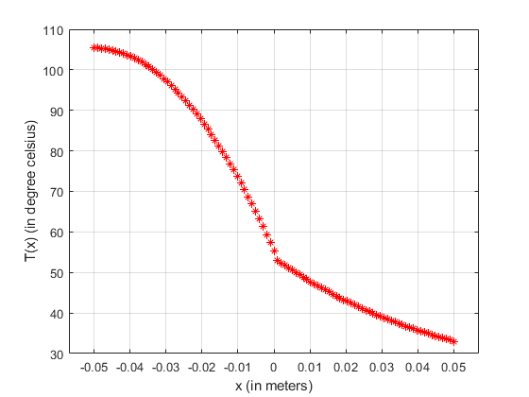

The temperature is converted from Kelvin to degree Celsius before plotting for easier understanding.

**Solution:**

1. ***Free Body Diagram***

“K1” and “k2” are the spring constants. “b” is the damper as shown in the original figure.

1. ***Differential equations:***

m $\ddot{x}$ = - $k_{1}$ x - b $\dot{x}$ + k(z-x)

m $\ddot{x}$ + $k_{1}$ x + b $\dot{x}$ + $k_{2}$ x = $k_{2}$ z

$\ddot{x}$ = $\frac{-k_{1} + k_{2}}{m}$ x - $\frac{b}{m}\dot{x}$ + $\frac{k_{2}}{n}$ z

1. ***Simulink Model:***

***Simulink Output:***

The signal input to the system is of 6 seconds, but the simulation time was set to 8 seconds to visualize the behavior after the input signal becomes constant.

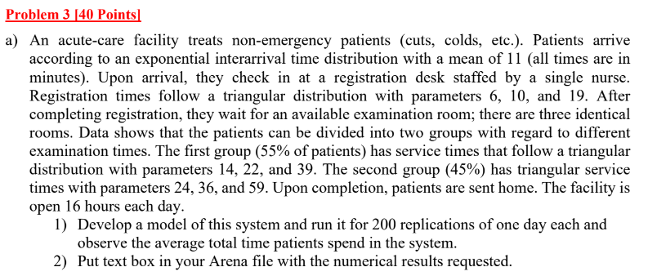

**Solution:**

1. ***Arena Model:***

***Output:***

Text box added in arena file as requested.

**Solution:**

Making a copy of the first model and making edits.

***Arena model for 3B***

***Output:***

Text box added in the solution as requested.

Arena models for each question is attached individually in the submission.